Principles of big data Project Deployment

Contents

1. Deployment in Heroku
2. Containerizing using Docker

By:

Pallavi Desai

Saitejaswi K

Anusha Palla

**Deployment in Heroku**

* Heroku is Platform as service cloud

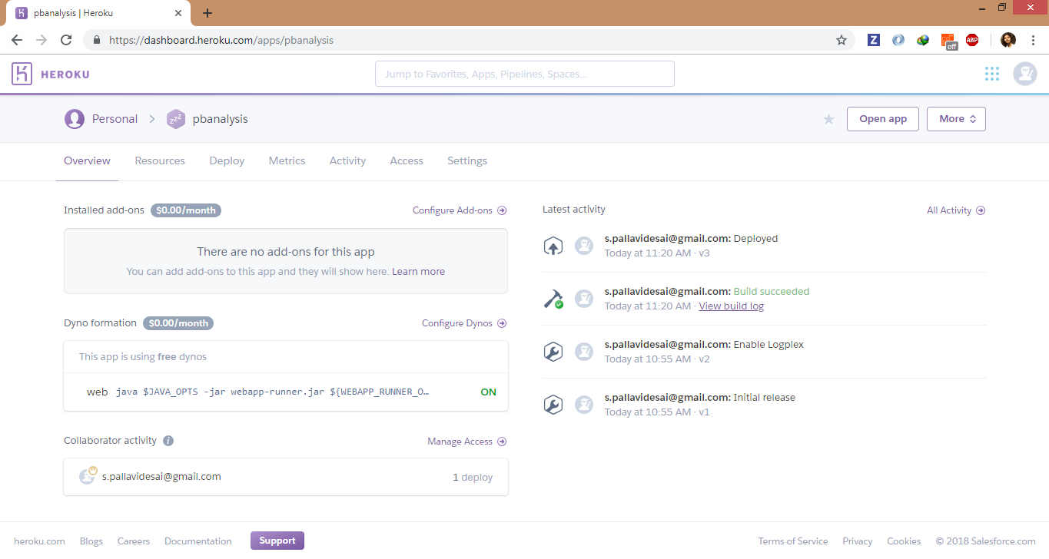

* It is free to use for students

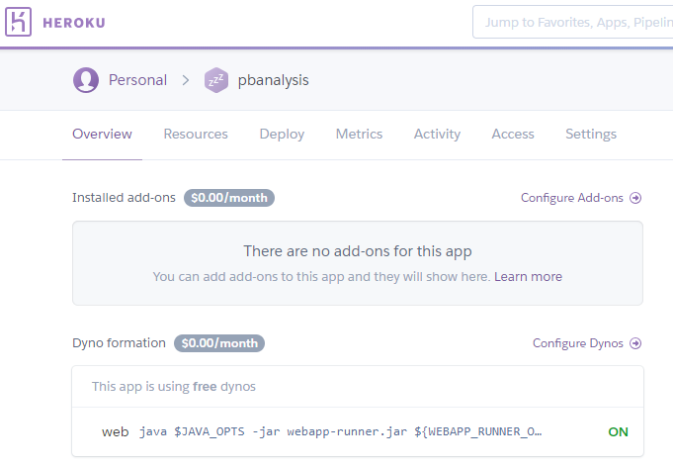

* We have deployed our war file of project in heroku

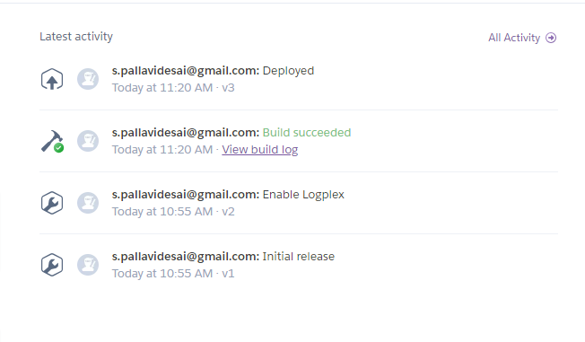

**Containerizing using Docker**

This zip file attached with this document contains war file along with Dockerfile and tweets collected.

Step 1: Unzip the document. There is a Dockerfile in it , which you need to build.

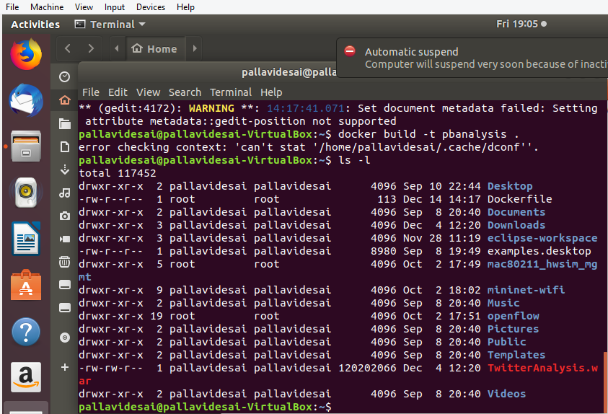

Step 2: Install Docker on your system

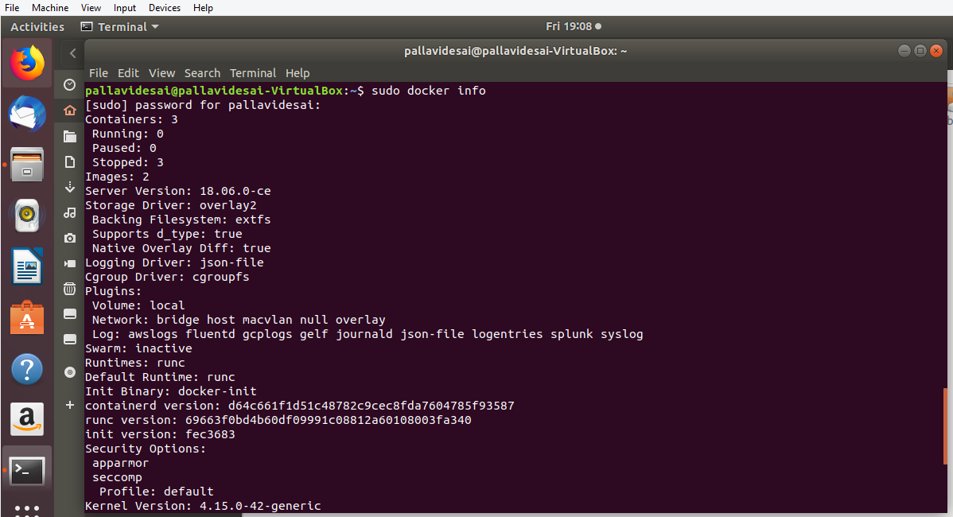

Step 3: Build the Docker as shown below

Command : docker build –t pbanalysis .

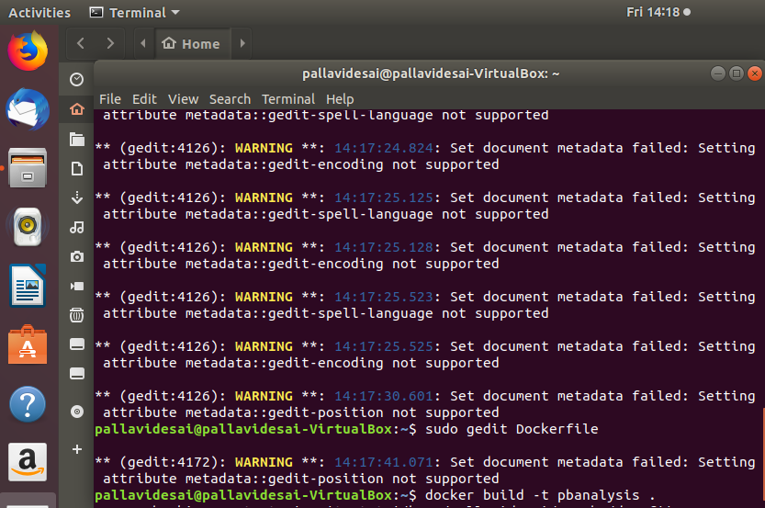

Step 4: Run the image on your system

Command : docker run pbanalysis

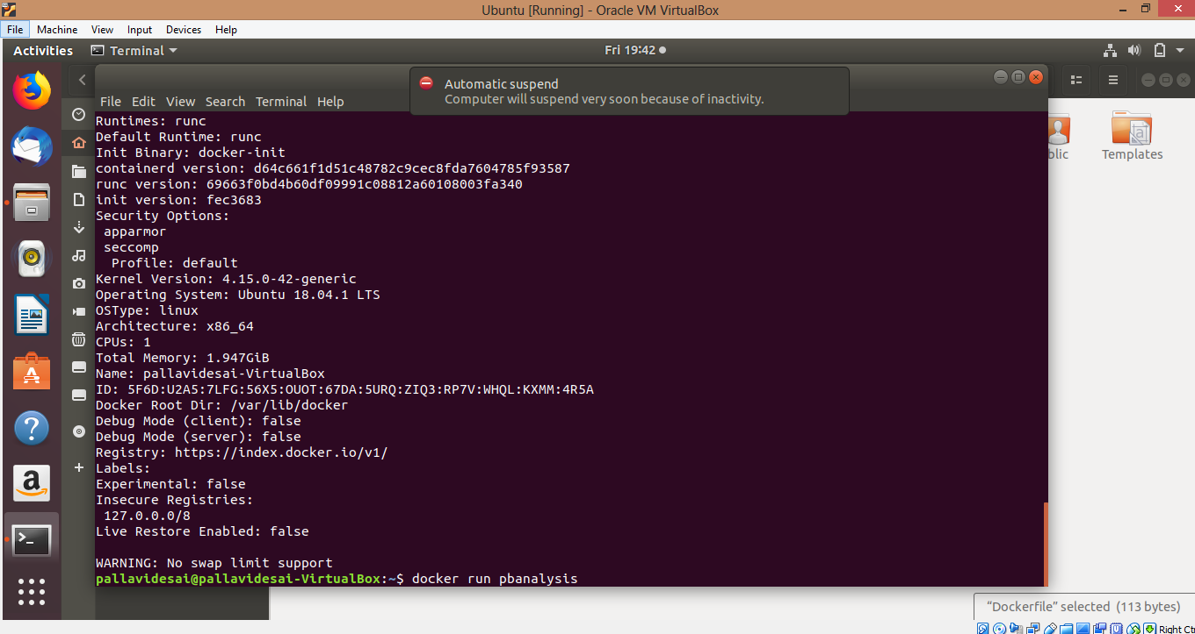

You can see quries running in your terminal.